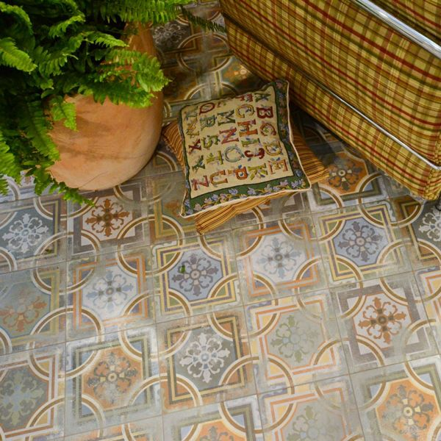**Comillas Patchwork Floor Tiles:**

## **Product Description**

For an aged, vintage look that will never go out of style, our Comillas Patchwork Floor tiles are the tile you're looking for! They feature a multitude of muted colours, from blue through orange, to complement your interior design choices and create a feature floor inspired by classic design.

**What's special about these tiles?**

> Aged, muted colourway

> Characterful pattern design

> Crafted from durable ceramic

> Matt finish

**Try before you buy**

If you'd like to take a closer look, why not order a sample tile? Samples are a great way to get a feel for a tile's true colour and texture, and you can see how it looks in your chosen room!

## **Product INFO**

* Product ID: 44853
* Tiles Per SQM: 25
* Sale by: Per SQM
* Size: 200x200x9mm
* Weight: 0.74 KG
* Material Type: Ceramic
* Finish: Matt
* Colour: Sage Green
* Suitability: Floors, Walls
* Rectified Edge: No
* Underfloor Heating: Yes
* Thickness (mm): 9